Industrial Computer
QY-U330

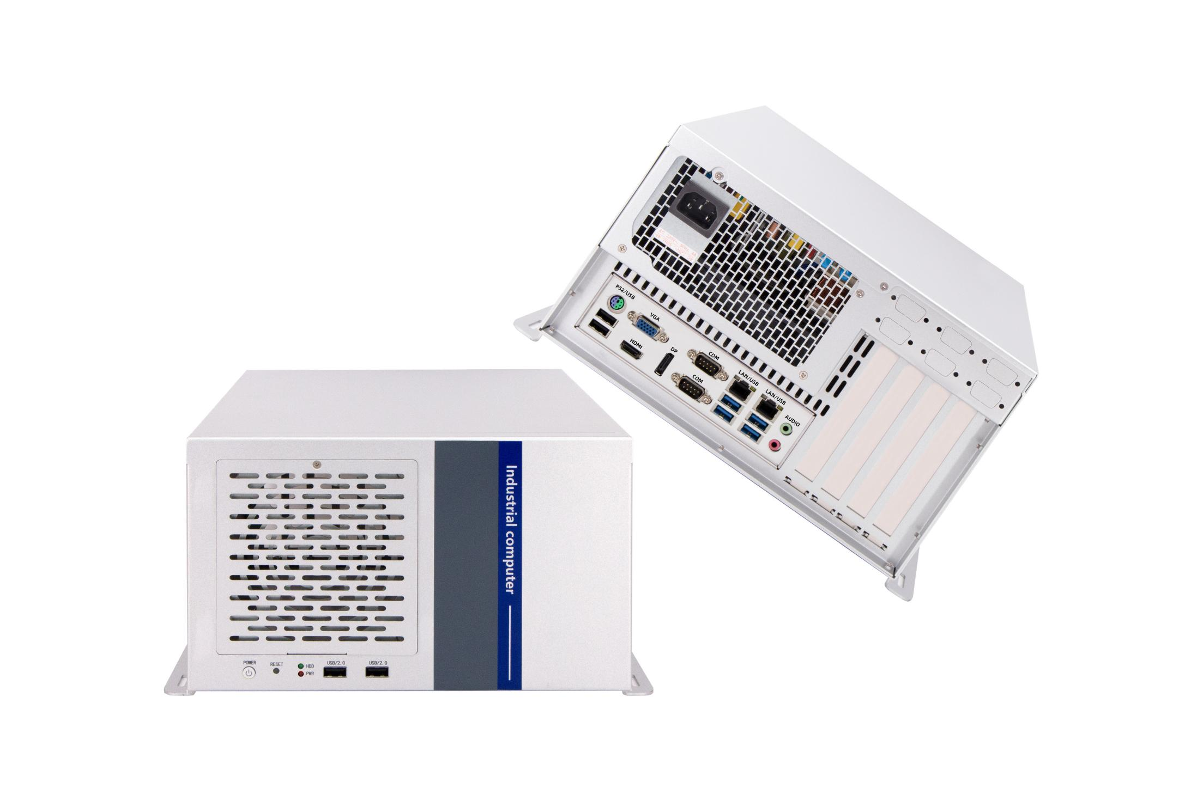

Products Features:
- Industrial-Grade Industrial Computer
- Support Micro-ATX or Mini-ITX type Mother Board
- Intel 4/6/8/9/10/11/12/13/14th-i3/i5/i7/i9 desktop CPU
- Standard ATX power, 300w to 1300w
- More expansion slots, Mini PCIE / M.2 / PCIE / PCI
- Support remote power on and off
- -30℃~70℃ Temperature Can Keep 24/7 Work Stably
- Anti-Static, Anti-Pulse, Anti-Surge, Anti-Radiation
QY-U330
1-1.B85 Mother Board Specification:
Mother Board Model | QY-B85-ATX-V11
Chipset | Intel B85, Support Intel Core 4th-i3/i5/i7 / Pentium / Celeron desktop CPU, LGA 1150
Memory | Support DDR3-1333 / 1600 MHz, 2*SO-DIMM Slots, Up to 16GB
Storage | 1*MSATA SSD slot  4*SATA SSD slots
Display | 1*DP: Resolution max up to 2560*1440@60Hz  1*HDMI: Resolution max up to 2560*1440@60Hz  1*VGA: Resolution max up to 1920*1080@60Hz
Expansion | 1*PCIE 16x slot  1*PCIE 4x slot  2*PCI slots  1*Mini PCIE slot, support 4G and WIFI module
Ethernet | 2*Intel I210V LAN Chip (10 / 100 / 1000 Mbps, RJ-45 Type)
USB | 4*USB 3.0 (Type-A)  2*USB 2.0 (Type-A)  5*USB 2.0 (Header)
COM | 2*RS-232 / 422 / 485 (DB9 type)  4*RS-232 (Header)
Audio | 1*Line-out+1*Line-in+MIC
Mother Board Type | Micro-ATX

QY-U330
1-2.Z390 Mother Board Specification:
Mother Board Model | QY-Z3932-X
Chipset | Intel Z390, Support Intel Core 6/8/9th-i3/i5/i7 / Pentium / Celeron desktop CPU, LGA 1151
Memory | Support DDR4-2666 MHz, 2*Non-ECC U-DIMM Slots, Up to 64GB
Storage | 1*M.2 NVME/SATA SSD slot  4*SATA 3.0 slots
Display | 1*DVI: Resolution max up to 1920*1200@60Hz  1*VGA: Resolution max up to 1920*1200@60Hz  1*HDMI: Resolution max up to 14096*2160@30Hz
Expansion | 1*PCIE 16x slot+1*PCIE 4x slot  2*PCI slots  1*Mini PCIE slot, support 4G and WIFI module
Ethernet | 2*Intel (i219V+i225V) LAN Chip (10 / 100 / 1000 / 2500 Mbps, RJ-45 Type)
USB | 4*USB 3.2 (Type-A)  2*USB 2.0 (Type-A)  5*USB 2.0 (Header)
COM | 1*RS-232 / 422 / 485 (DB9 type)  1*RS-232 / 485 (DB9 type)  4*RS-232 (DB9 type)
Audio | 1*Line-out+1*Line-in+1*MIC
Mother Board Type | Micro-ATX

Mother Board Model | QY-588-Y
Chipset | Intel H420E, Support Intel Core 10/11th-i3/i5/i7/i9 / Pentium / Celeron desktop CPU, LGA 1200
Memory | Support DDR4-2400/2666/2933 MHz, 2*DIMM Slots, Up to 64GB
Storage | 1*M.2 SATA SSD slot  3*SATA SSD 3.0 slots
Display | 1*VGA: Resolution max up to 1920*1200@60Hz  1*HDMI: Resolution max up to 4096*2160@60Hz
Expansion | 1*PCIE 16x Slot  1*PCIE 4x Slot  2*PCI
Ethernet | 1*Intel i219V+1*Intel 210V LAN Chip (10 / 100 / 1000 Mbps, RJ-45 Type)
USB | 6*USB 3.2 (Type-A)  4*USB 2.0 (Header)
COM | 1*RS-232/422/485 (DB9 Type)  1*RS-232/485 (DB9 Type)  4*RS-232 (DB9 Type)
Audio | 1*Line-out+1*MIC
Mother Board Type | Micro-ATX
QY-U330
1-3.H420E Mother Board Specification:

Mother Board Model | QY-M6162-H
Chipset | Intel H610, Support Intel Core 12/13/14th-i3/i5/i7/i9 / Pentium / Celeron desktop CPU, LGA 1700
Memory | Support DDR4-3200 MHz, 2*U-DIMM Slots, Up to 64GB
Storage | 1*M.2 SATA SSD slot  3*SATA3.0 SSD slots
Display | 1*VGA: Resolution max up to 1920*1200@60Hz  1*HDMI: Resolution max up to 4096*2160@30Hz  1*DP：Resolution max up to 7680*4320@60Hz
Expansion | 1*PCIE 16x slot  2*PCIE 4x slots  1*PCI slot  1*Mini PCIE slot, Support 4G / WIFI module
Ethernet | 1*Intel i210V+1*Intel i219V LAN Chip (10 / 100 / 1000 Mbps, RJ-45 Type)
USB | 4*USB 3.0 (Type-A)  7*USB 2.0 (Type-A)  2*USB 2.0 (Header)
COM | 1*RS-232/422/485 (DB9 Type)  1*RS-232/485 (DB9 Type)  4*RS-232 (DB9 Type)
Audio | 1*Line-out1*MIC
Mother Board Type | Micro-ATX
QY-U330
1-4.H610 Mother Board Specification:

QY-U330
2.Device Specification:
Power Input | ATX Power Module (300w / 500w / 800w / 1000w / 1300w)
Power Input | Support Auto-Start
Working Temperature | -30℃~70℃, Support 24/7 Working
Structure | Fully Enclosed Aluminum Alloy Material
Heat Dissipation | Fan Design
Installation | Desktop / Embedded
Size | 315mm*310.5mm*174.8mm
System | Windows and Linux
Mother Board Type | Micro-ATX / Mini-ITX

QY-U330
3.Ordering Information:
Model | Chipset | CPU | LAN | USB | COM | RAM | Display | SSD | Expansion
QY-U330 | B85 | 4th | 2 | 4*3.0  7*2.0 | 2*RS-232/422/485  4*RS-232 | 2*DDR 3  Up to 16GB | 1*HDMI  1*DP  1*VGA | 1*MSATA  4*SATA | 1*Mini PCIE  1*PCIE 16x  1*PCIE 4x  2*PCI
QY-U330 | Z390 | 6th/8th/9th | 2 | 4*3.2  7*2.0 | 6*RS-232 | 2*DDR 4  Up to 64GB | 1*VGA  1*HDMI | 1*M.2 NVME  4*SATA | 1*Mini PCIE  1*PCIE 16x  1*PCIE 4x  2*PCI
QY-U330 | H420E | 10th/11th | 2 | 6*3.2  4*2.0 | 1*RS-232/422/485  1*RS-232/485  4*RS-232 | 2*DDR 4  Up to 64GB | 1*VGA  1*HDMI | 1*M.2 SATA  3*SATA | 1*PCIE 16x  1*PCIE 4x  2*PCI
QY-U330 | H610 | 12th/13th/14th | 2 | 4*3.0  9*2.0 | 1*RS-232/422/485  1*RS-232/485  4*RS-232 | 2*DDR 4  Up to 64GB | 1*HDMI  1*VGA  1*DP | 1*M.2 SATA  3*SATA | 1*Mini PCIE  1*PCIE 16x  2*PCIE 4x  1*PCI

4.System Information:

CPU | System
4th / 6th | Windows 7 / 10 and Linux
8th / 9th / 10th / 12th / 13th / 14th | Windows 10 / 11 and Linux

5.Fittings Information:
QY-U330
RAM | DDR 3 | 4GB / 8GB
RAM | DDR 4 | 4GB / 8GB / 16GB / 32GB
SSD | MSATA | 64GB / 128GB / 256GB / 512GB / 1TB
SSD | M.2 NVME / SATA | 128GB / 256GB / 512GB / 1TB / 2TB / 4TB
SSD | SATA | 120GB / 128GB / 240GB / 256GB / 480GB / 512GB / 960GB / 1TB / 2TB / 4TB
GSM Module | 4G | 4G+GPS
WIFI Module | 7260AC / AX210
ATX Power | 300w / 500w / 800w / 1000w / 1300w

6.Package List:

Power Cable | 1*Power Cable

7.Dimensions:
QY-U330

